Homework #4
(Module 4: Voltage Control Devices)

Question 1: Which of the following statements is not correct?
- Current flowing in an overhead distribution line causes a voltage drop.
- An unloaded distribution line can experience a voltage rise.
- Voltage drop is only caused by resistance.
- Voltage drop in phase A is dependent of the load on phase B or C.
Question 2: If over a given period of time a customer has a minimum voltage of 116.3V and a maximum voltage of 121.7V, what is the percent regulation for that customer?
- 3.2%
- 3.7%
- 4.4%
- 4.6%
Question 3: For the one line drawing, and associated phasor diagram, which phasor diagram most accurately represents the addition of a shunt capacitor at the node V_{R}? Assume that I_{C} is the current injected by the shunt capacitor and that the load has a lagging power factor.

- Phasor diagram 1:
- Phasor diagram 2:
- Phasor diagram 3:
- Phasor diagram 4:

Question 4: Assuming a standard voltage regulator, +/- 16 steps, on a 12.47 kV system, how much will the line to neutral output voltage at the regulator terminals change if the tap positions are increased by 13 taps?
- 8V
- 585V
- 45V
- -45V
Question 5: Assuming a 450KVAR capacitor bank is operated in VAR control, what would be an appropriate dead-band?
- 100kVAR
- 400kVAR
- 450kVAR
- 600 kVAR
Question 6: Given the ZIP model below, what would be the difference in real and reactive power draw between 123.0V and 116.5V? Assume a nominal energy consumption of 183.4W and 43.77VAR.
Z% : 60% I%:20% P%:20%
Z_{θ}, 20°, I_{θ},-30°,P_{θ} a -15°
- ΔP=19.4W ΔQ=3.2VAR
- ΔP=17.2W ΔQ=8.9VAR
- ΔP=12.6W ΔQ=-10.8VAR
- ΔP=18.5W ΔQ=5.5VAR
Question 7: Which statement best describes the capabilities of the traditional ZIP model?
- It is able to the capture real and reactive power values, but it is time-invariant and cannot accurately reflect energy consumption.
- It is able to model traditional electrical loads such incandescent light bulbs and heating, but it is not an accurate representation for new loads such as switched power supplies.
- It is no longer a widely used representation for end use load.
- The ZIP model is able to capture real power consumption but not reactive power consumption.
Question 8: Given the plot below, what is the best approximation of voltage regulation for each phase?
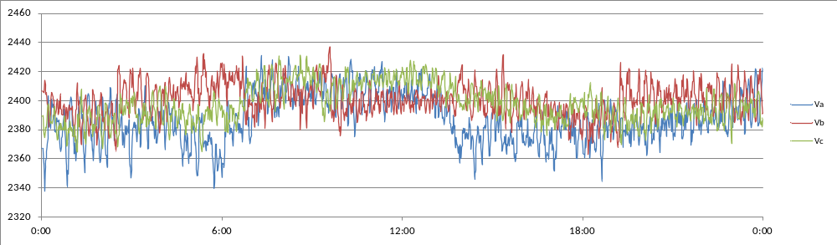
- Phase A:5.2% Phase B:2.6% Phase C:7.5%
- Phase A:3.8% Phase B:3.0% Phase C:2.7%
- Phase A:4.2% Phase B:6.9% Phase C:1.2%
- Phase A:6.7% Phase B:5.3% Phase C:4.3%
Question 9: What is the most accurate statement about the power plot below?
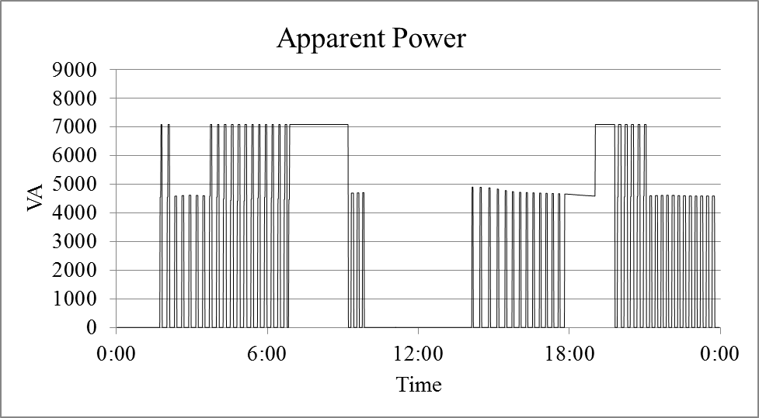
- This is a plot for a large number of end use customers.
- The data was collected with a system that experience multiple data drop outs.
- The plot is of a single device with multiple operational states.
- The plot was simulated using a ZIP model.
Question 10: Which of the following factors does not affect the energy consumption of a single family residence?
- Size of the secondary transformer.
- Construction of house.
- Type of lighting.
- Type of heating.

